Bo Lin AEM 685

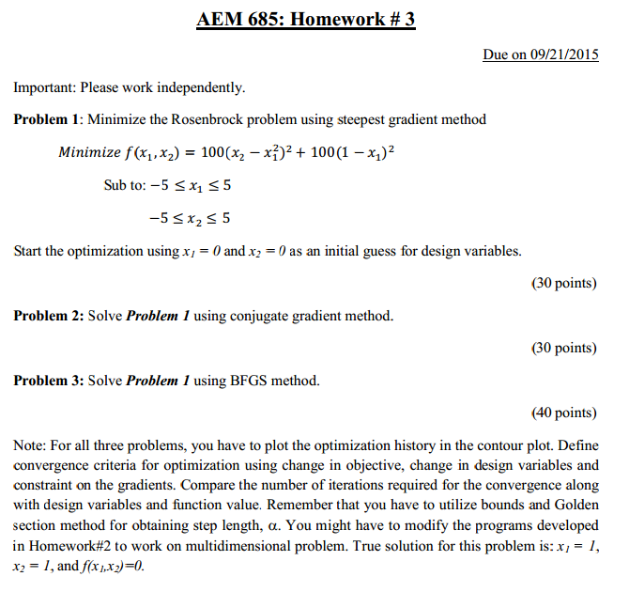

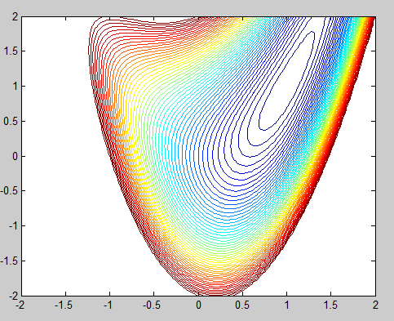

1 Steepest Gradient Method

x=[0;0];

tol=0.0001;

dx=0.01;

a=1.61803;

b=0.0005;

f = @(x)100*((x(2)-x(1)^2))^2+100*(1-x(1))^2;

n=0;

while(1)

A=0;

S=@(x) -1*gradientlin(f,dx,x);

ST=S(x)'

minf=@(A) f(x+(A*ST));

GOLD=GoldSection_1Var(minf,tol,A,a,b,10)

A=GOLD(1)

E=feval(f,x)-feval(f,x+(A*ST))

p=A*ST

x=x+p

if abs(E)<=tol

break

end

n=n+1;

end

n

%%%%%%%%%%%%%%%%%%%%%%%%%%%%%%%%%%%%%%%%%

function gradix=gradientlin(functname,dx,x)

format compact

n=size(x);

N=eye(n(1));

DeltaX=dx.*N*ones(n(1),1)+[0;0];

xtemp=x;

for i=1:n;

x=xtemp;

D=[0;0];

D(i)=DeltaX(i);

w1=feval(functname,x+D)-feval(functname,x-D)

w2=2*DeltaX(i);

gradix(i)=w1/w2;

end

%%%%%%%%%%%%%%%%%%%%%%%%%%%%%%%%%%%%%%%%%%%

Result

n =

14

History =

0 0

0.585405221831637 0

0.599897354555856 0.375057787841855

0.735228916673096 0.370145118833006

0.753394643436985 0.590735990513549

0.827042977906785 0.584679798773472

0.838580806751846 0.719380340159746

0.882397672612223 0.715620529137002

0.891533005523234 0.807938179299263

0.919052118245330 0.805198572500717

0.939549551235552 0.903403706891060

0.957917619689936 0.899574898361340

0.998890117109663 1.00014667762305

0.999884140085490 0.999729471102029

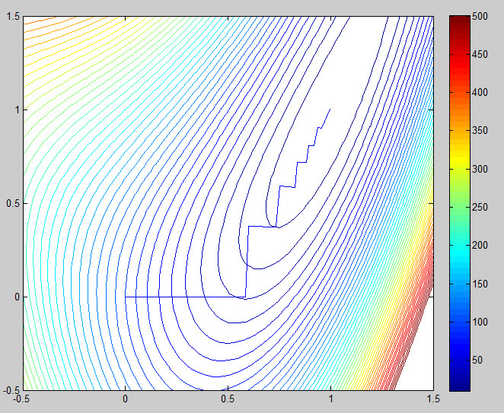

2 Conjugate gradient method

x1=linspace(-2,2,100);

x2=linspace(-2,2,100);

[X1,X2]=meshgrid(x1,x2);

f = @(x1,x2)100*((x2-x1.^2)).^2+100*(1-x1).^2;

f(X1,X2);

Z=f(X1,X2);

contour(X1,X2,Z,0:10:500)

hold on

x=[0;0];

tol=0.0001;

dx=0.01;

a=1.61803;

b=0.0005;

f = @(x)100*((x(2)-x(1)^2))^2+100*(1-x(1))^2;

n=1;

dF=gradientlin(f,dx,x);

aa=dF*dF';

while(1)

x1history(n)=x(1);

x2history(n)=x(2);

xtemp=x;

A=0;

S=@(x) -1*gradientlin(f,dx,x);

ST=S(x)'

minf=@(A) f(x+(A*ST));

GOLD=GoldSection_1Var(minf,tol,A,a,b,10)

A=GOLD(1)

%feval(f,x)

%feval(f,x+(A*ST))

if A==0

break

end

p=A*ST

x=x+p

dF=gradientlin(f,dx,x);

bb=dF*dF';

beta=bb/aa;

S=@(x) -1*gradientlin(f,dx,x)+beta*ST';

ST=S(x)';

aa=bb;

slope=S(x)*dF';%ST*dF

if slope>=0

S=@(x) -1*gradientlin(f,dx,xtemp);

end

A=0;

minf=@(A) f(x+(A*ST));

GOLD=GoldSection_1Var(minf,tol,A,a,b,10)

A=GOLD(1);

p=A*ST;

x=x+p;

E=feval(f,x)-feval(f,x+(A*ST));

if abs(E)<=tol

break

end

n=n+1;

end

n

history=[x1history' x2history']

plot(x1history,x2history)

axis([-0.5 1.5 -0.5 1.5]);

%%%%%%%%%%%%%%%%%%%%%%%%%%%%%%%%%

Result

n =

12

history =

0 0

0.9584 0.9769

0.9893 0.9697

0.9875 0.9745

0.9912 0.9757

0.9899 0.9791

0.9930 0.9803

0.9919 0.9829

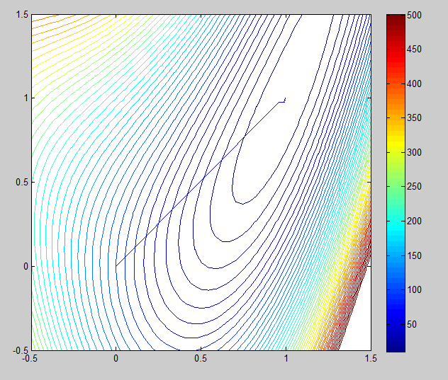 0.9944 0.9840

0.9934 0.9861

0.9954 0.9869

0.9946 0.9887

0.9989 1.0001

0.9999 0.9997

3 BFGS Method

n =

6

history =

0 0

0.5854 0

0.8978 0.8991

0.9809 0.9483

1.0009 1.0003

0.9999 0.9997



%BFGS method

x1=linspace(-2,2,100);

x2=linspace(-2,2,100);

[X1,X2]=meshgrid(x1,x2);

f = @(x1,x2)100*((x2-x1.^2)).^2+100*(1-x1).^2;

f(X1,X2);

Z=f(X1,X2);

contour(X1,X2,Z,0:10:500)

hold on

%%%%%%%%%%%%%%%%%%%%%%%%%%%%%%%%%%%%%%%

x=[0;0]; %starting point

tol=0.0001;

dx=0.01;

a=1.61803;

b=0.0005;

f = @(x)100*((x(2)-x(1)^2))^2+100*(1-x(1))^2;

n=1;%starting iteration

SIZE=size(x);

H=eye(SIZE(1));%H starting as I matrix

xold=x; %xq-1

while(1)

x1history(n)=x(1); %save x data to xhistory

x2history(n)=x(2);

S=@(x) gradientlin(f,dx,xold);

ST=-H*S(x)' %Search direction

A=0; %initial A

minf=@(A) f(x+(A*ST));

GOLD=GoldSection_1Var(minf,tol,A,a,b,10)

A=GOLD(1)

xold=x;

x=x+A*ST%update x

p=x-xold;%p is the same

y=gradientlin(f,dx,x)-gradientlin(f,dx,xold);% 3.12b y is y'

sigma=p'*y';%3.22a

t=y*H*y';%3.22b

coe1=(sigma+t)/(sigma.^2);

coe2=1/sigma;

UD=coe1*p*p'-coe2*(H*y'*p'+p*(H*y')');%3.20

H=H+UD;%3.19 update H

E=gradientlin(f,dx,x)-gradientlin(f,dx,xold)

xold=x;

if norm(E)<=tol

break

end

n=n+1;

end

n

history=[x1history' x2history']

plot(x1history,x2history)

axis([-0.5 1.5 -0.5 1.5]);